**GOVERNMENT ARTS COLLEGE, OOTY**

**DEPARTMENT OF PHYSICS**

**ILLUMINATING INSIGHTS OF**

**INDIA’S AGRICULTURAL CROP PRODUCTION ANALYSIS**

**(1999-2021)**



MENTOR:DR.J.MANIKANTAN

SUBMITTED BY

TEAM LEADER : JISHNUNATH.K.V(2122CO211)

TEAM MEMBER 1: LOKESHKUMAR.C(2122C0212)

TEAM MEMBER 2: MANAVALAN.M(2122C0213)

TEAM MEMBER 3: MOHAMMED SHARIFF.A.L(2122C0214)

**GOVERNMENT ARTS COLLEGE ,**

**UDHAGAMANDALAM**

**DEPARTMENT OF PHYSICS**

MENTOR:DR.J.MANIKANTAN

TEAM LEADER:JISHNUNATH.K.V

TEAM MEMBER 1:LOKESHKUMAR.C

TEAM MEMBER 2:MANAVALAN.M

TEAM MEMBER 3:MOHAMMED SHARIFF.A.L

**ILLUMINATING INSIGHTS OF**

**INDIA’S AGRICULTURAL CROP PRODUCTION ANALYSIS**

**(1999-2021)**

1.INTRODUCTION

**1.1Overview**

According to The World Bank, India is a global agricultural powerhouse. It is the world's largest producer of milk, pulses, and spices, and has the world's largest cattle herd (buffaloes), as well as the largest area under wheat, rice and cotton. It is the second largest producer of rice, wheat, cotton, sugarcane, farmed fish, sheep & goat meat, fruit, vegetables and tea. While agriculture’s share in India’s economy has progressively declined to less than 15% due to the high growth rates of the industrial and services sectors, the sector’s importance in India’s economic and social fabric goes well beyond this indicator.

**1.2 Summary**

| **S.No** | **Summary Statement** | **Stats if any** |
| --- | --- | --- |
| 1 | Rice is the major choice of farmers with 21,175 records found of rice production. Almost all states are into rice production | NA |
| 2 | Uttar Pradesh is the biggest producer of crops in India | Total 4,18,25,67,000 Tonnes of crop produced |
| 3 | 2018-19 was the best year with maximum crop production in India | Total 1,14,93,77,000 Tonnes of crop was produced |
| 4 | 1997-98 was the year with least production. This is potentially because of the lack of framework and mechanism to collect crop production data across the country | Total 55,91,10,900 Tonnes of crops were produced |
| 5 | West Bengal is the highest producer of Rice as per the records | Total of 33,89,84,869 Tonnes of Rice was produced in West Bengal |

**2.PROBLEM DEFINTION & DESIGN THINKING**

**2.1 EMPATHY MAP**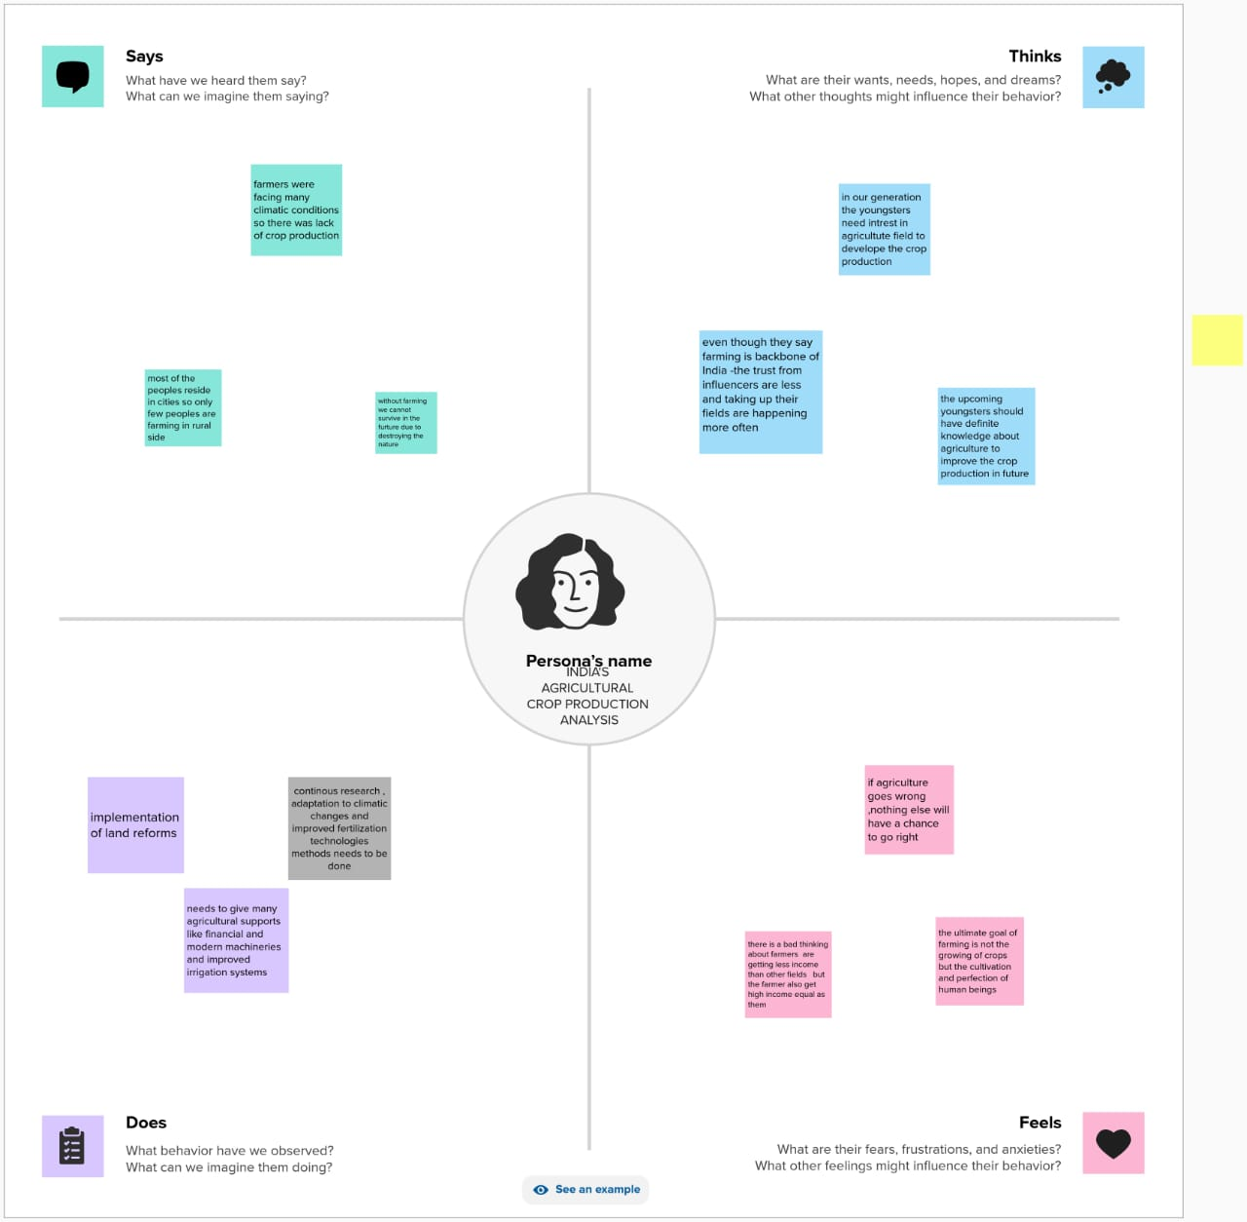

2.2 IDEATION & BRAINSTROMING MAP

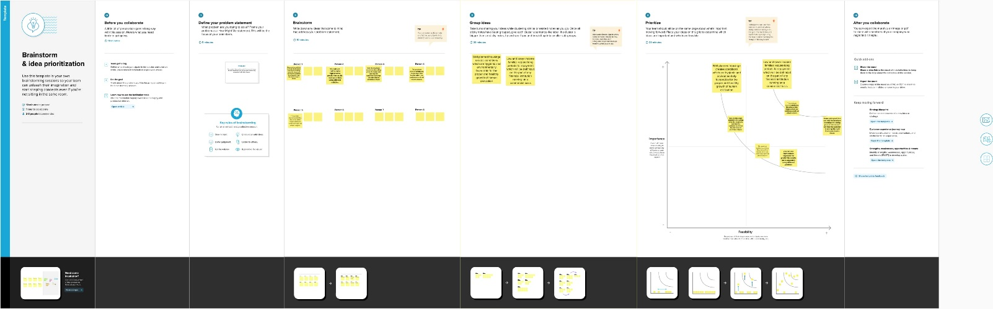

3.RESULT

**3.1 :DASHBOARD**

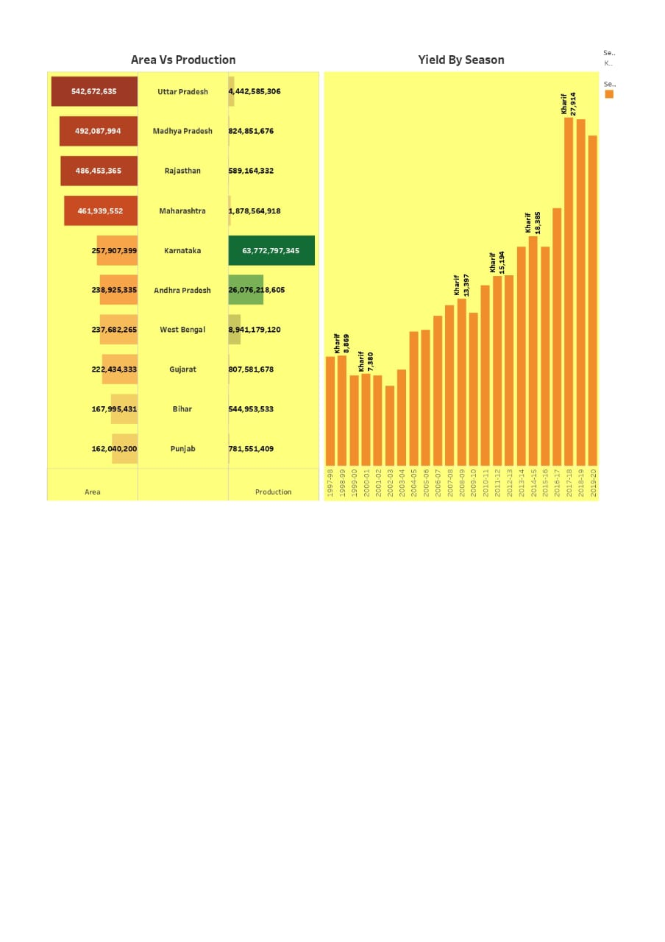

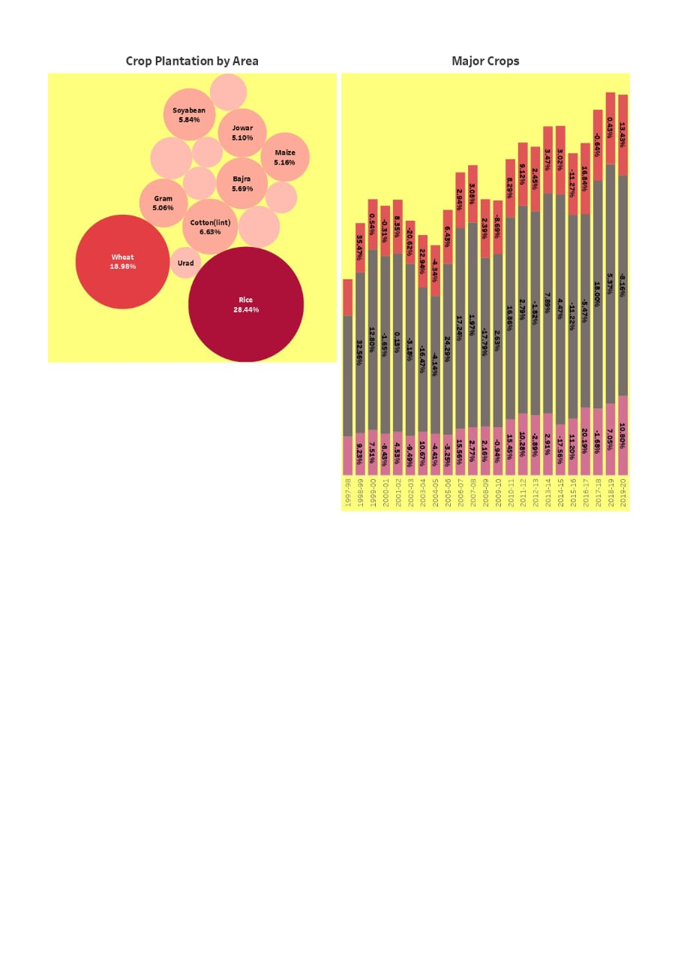

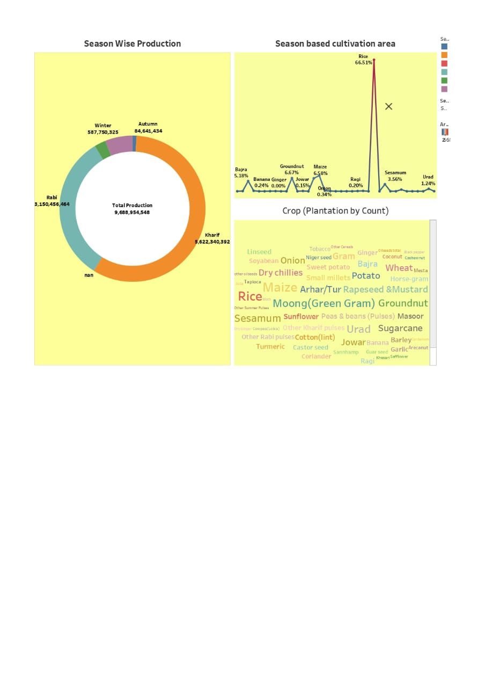

**3.2 STORY**

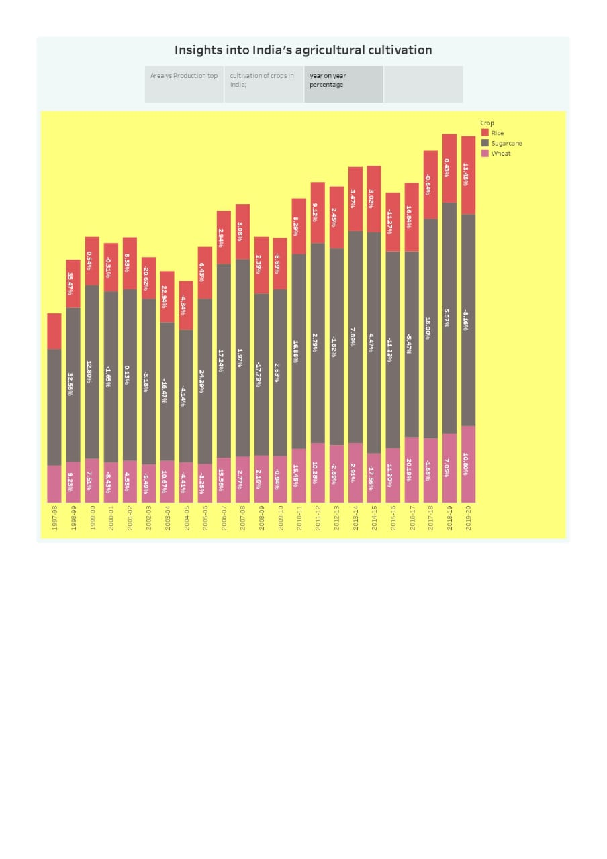



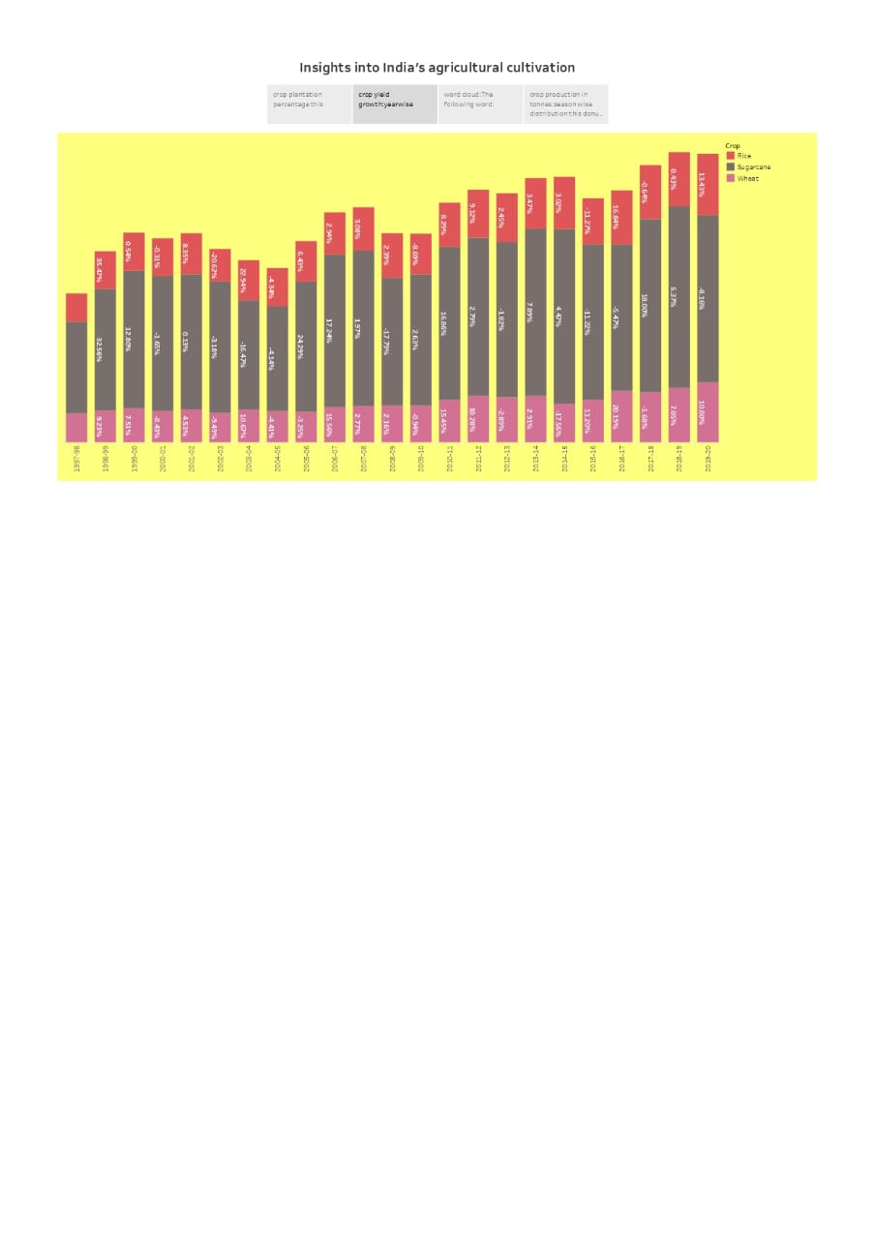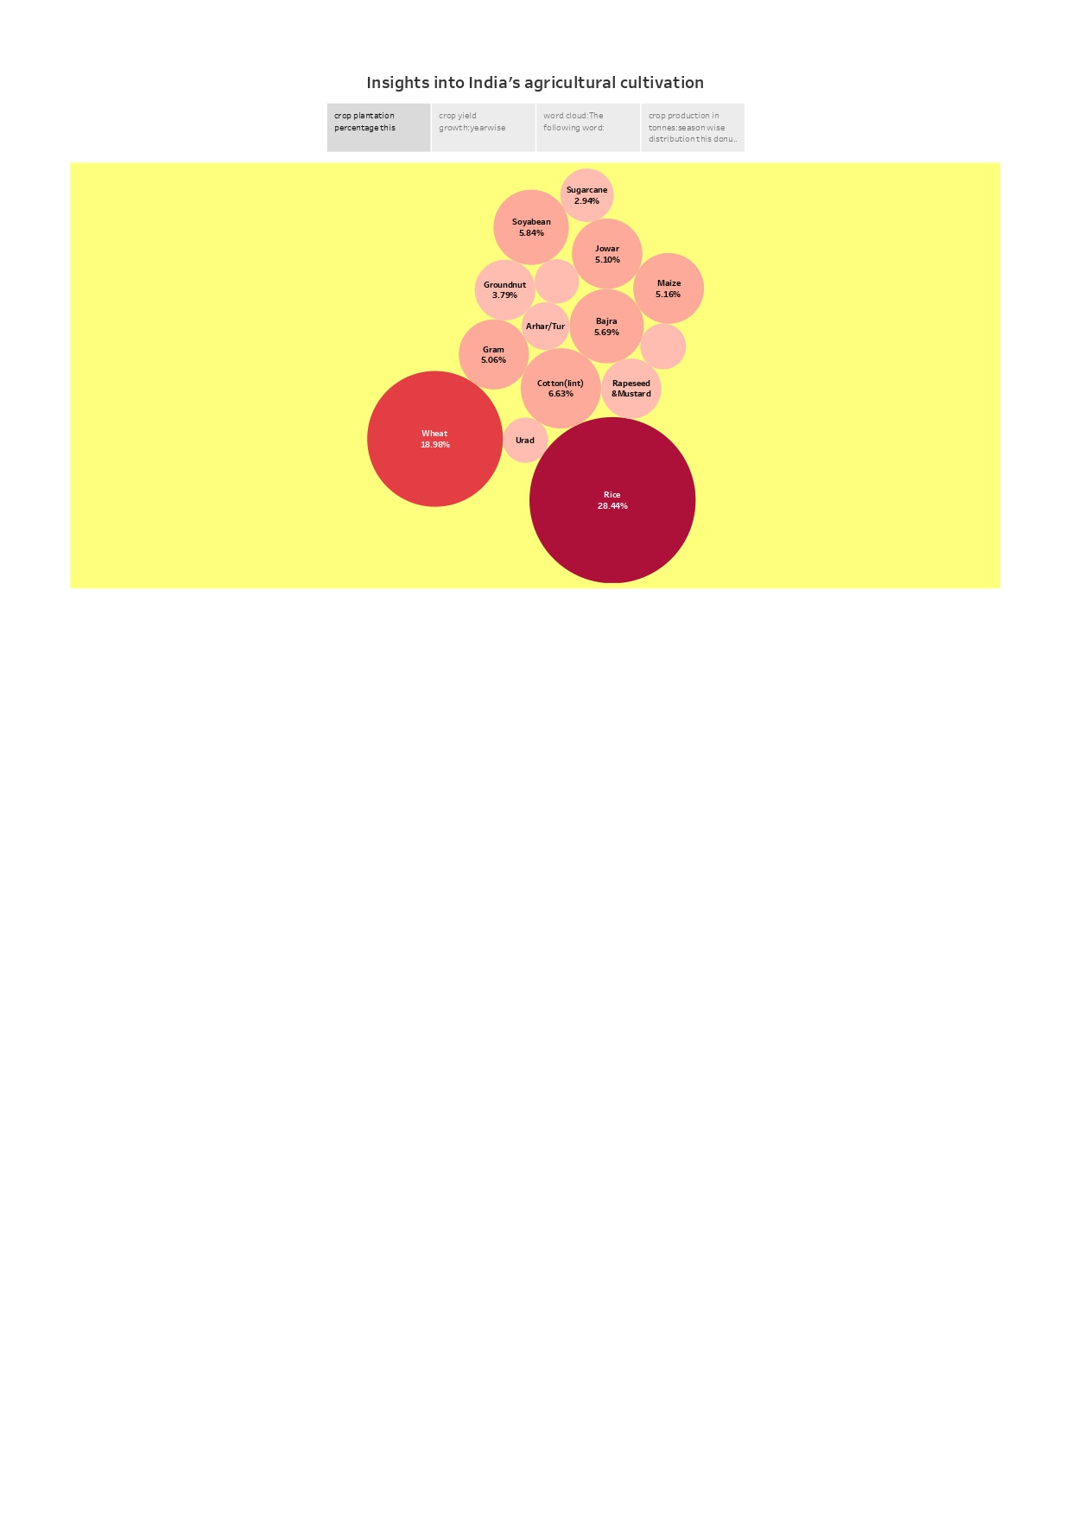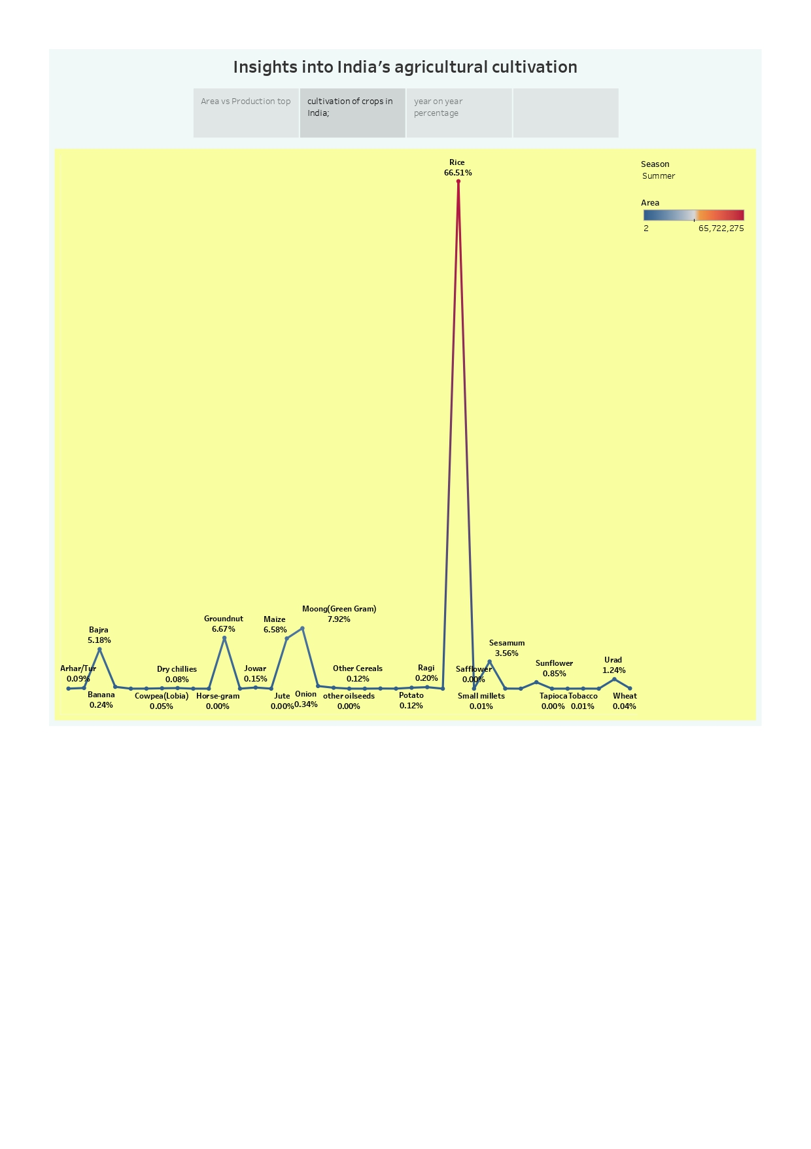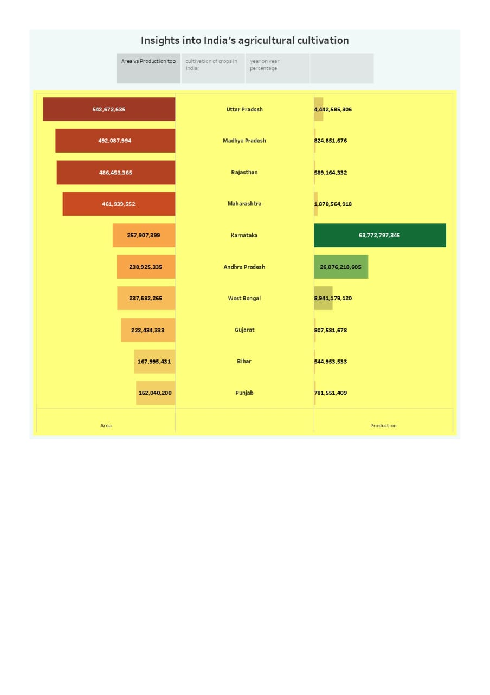

**4.ADVANTAGES AND DISADVANTAGES**

**4.1 ADVANTAGES**

### 1. Natural Environment

Organic farming usually goes down in a natural environment. Unnecessary enclosures are not used for the crops or plants. This way the productivity is increased and is way better compared to closed spaces. An open and natural area for growing the crops would give them wild and instinctive growing nature. This is ideal for the crops and is one of the factors that leads to the plants being organic.

### 2. No Chemicals

Unlike other forms of farming, organic farming does not involve any artificial sources like chemicals to drive away pests or to speed up the process of farming. These chemicals are often used in commercial and industrial farming methods. However, organic farming stays true to its title. Its method is true to its natural core and does not use anything that may be of harm to its consumers. Any type of chemical is not entertained in the organic farming industry.

### 3. Eye On You

Unlike any other procedure, organic farming has a very strict supervision schedule. The reason for this extreme regulation is because of the importance to keep the label organic. It is very difficult to do so as most brands use artificial aspects in their farming. There are various **methods of organic farming** and its standards must be maintained in order to remain organic. This ensures that customers buying the end product receive what they’re truly looking for.

### 4. Environmentally Friendly

Among the **advantages of organic farming**, this one stands out the most. Today, almost the entire sector of industrial farming consists of chemicals that ruin the environment. However, when you have something like organic farming to replace it, a huge benefit is received. Organic farming does not use any form of chemical nor does any form of pollution happen because of it. This makes it way better than regular farming. The whole world suffers because of the ignorant methods of regular farming including animals. Organic farming is definitely the way to go.

### 5. Healthier And Tastier

Since non-organic farming produces results that are way too suspicious when eaten, it is obvious that it isn’t good for health either. **Organic farming in kerala** for example are known to keep the crops growing properly. They are given time and care unlike non-organic sectors that pump the results with chemicals in order for it to grow faster. These type of sectors are only commercial-minded and are least bothered about the satisfaction and health of the consumer. Since the fruits and vegetables grown organically are given longer time to flourish, they automatically are way better in terms of nutrition and taste.

**4.2 DISADVANTAGES**

### 1. Expensive Products

One of the major problems of organic farming methods is that sometimes it can get a bit costly. Some products related to organic farming are too expensive, leading to some common people to not be able to afford it. In a country like India where most of its livelihood are farmers, organic farming brings a huge problem to it. However, **organic farming in Tamil Nadu** have had some success stories.

### 2. More Labor

Organic farming is a sector that requires a lot of patience. This is because pests and others obstacles must be tackled manually. Unlike in non-organic farming, the use of pesticides and other chemicals are not permitted. This makes the work of the farmer harder as constant attention and care is needed. Due to the constant attention, a lot of time is consumed. Organic farming has to be executed well which needs a lot of time and not to forget weed-prevention.

### 3. High MRP

It is almost obvious that due to the extreme care taken to go along with organic farming, the results would be kept at a high price. Once sold to the market, most of the place is devoted to the sale of these organic fruits and vegetables. Most people do that approve of organic products because of this. The items sold in the market are half the price of non-organic products. So, we can say that organic items are expensive and not every consumer is willing to pay the price for it.

### 4. Cross Breeding Problem

The seeds of GMO plants once planted, create GMO crops. These crops then produce seeds and the pattern continues. This makes it very difficult to tell from the organic and GMO crops. This has become a huge problem in the organic farming sector. This could ruin the future of organic planting as a whole.

### 5. Labor Charges

Labor charges refer to the amount payable to someone who has been involved in the building ot working of something.  Like we said earlier, in organic farming ventures, the amount of labor is high and it takes a lot of time and patience to the get work done. If one is not able to do it by oneself, a lot of labor would be hired which increases the payment that those laborers deserve.

**5.FUTURE SCOPE**

* **Increases in food production:**
  + Indian agriculture has seen a dramatic increase in food production since introducing new technologies like the Green Revolution in agriculture practices. This trend is going to pick up more pace in the coming times.
  + There is a big shortfall between the amount of food we produce today and the amount needed to feed everyone in 2050. India’s population is expected to reach 1.64 billion people in 2050, up from its present population of 1.40 billion in 2022.
* **Changing Consumption Pattern:**
  + Due to globalisation, increase in household incomes and health consciousness the demand for fruits and vegetables, dairy products, fish and meat is going to increase in future.
  + Research, technology improvements, protected cultivation of high-value greens and other vegetables will be more. There will be more demand for processed and affordable quality products.
* **Land Consolidation:**
  + Fragmented land holdings and asset ownership will go through widespread consolidation, real, and virtual, to achieve economies of scale for smallholders.
  + Between 2010-2020, India lay down the foundations of taking rural citizens online. This decade will see the country’s **agricultural ecosystem migrate into a digital architecture** that helps overcome problems of fragmentation.
* **Increase in Demand for Processed Food:**
  + Cities lead the way in diet **diversification into high-value items**, and export markets expand. Cities will look to **secure their supply chains from external shocks** in the upcoming decade. Consumers, driven by a desire for freshness and immediate fulfilment, will pull **production of greens closer to them,** and have them on demand
* **Increase in Competitiveness:**
  + Due to more players in the field, **more competition is expected among the private player.** This is going to result in innovative products, better seeds, fertilisers, plant protection chemicals, customised farm machinery and feed for animals etc in cost-effective ways at competitive prices giving more returns on investment by farmers.

**6.CONCLUSION**

**>**Agriculture in India, like in many other developing countries, has achieved remarkable growth in the last four decades by large scale adoption of high yielding variety seed, use of chemical inputs and expansion of irrigation

**>**The sustainability of growth in agriculture has been viewed from a broader perspective encompassing geography, soil and agro-climatic conditions, rainfall, cropping pattern and overall environment.

**>**Both for productivity growth and conservation of resources, the role of technology, particularly the frontiers of biotechnology, irrigation technology, information technology has been highly emphasized.

**”THANK YOU”**